Section1:
Creation of virtual enviroment:
Create env:-
Python –m venv venv
Activate env:-
In linux: source venv/bin/activate
In window: venv/scripts/activate
Fastapi installation:-
Pip install fast api
Pip install “fastapi[standard]” recommended it gives extra dependencies
Fastapi running app:-
fastapi dev main.py
(another way using uvicorn) unicorn main:app --reload

First Fastapi app:
1.make venv
2.make main.py
3.write code inside main.py:
# Import the FastAPI class from the fastapi package
# This class is used to create a new FastAPI application instance
from fastapi import FastAPI

# Create an instance of the FastAPI class
# This 'app' object will be the main application that handles requests and responses
app = FastAPI()

# Define a route using the @app.get() decorator
# This tells FastAPI that when someone sends a GET request to the root URL ("/"),
# the following function (home) should be executed
@app.get("/")
def home():
# This function returns a JSON response
# The dictionary {"message": "Hello fast api"} will be automatically converted to JSON
return {"message": "Hello fast api"}

Fastapi app clean folder structure:
Two types of directery structure:-
- Horizontal Structure
- Vertical Structure

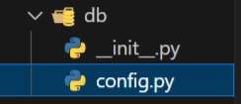
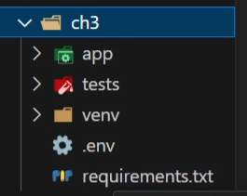
Vertical Structure: (Featured Based Structure):
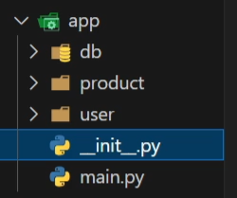

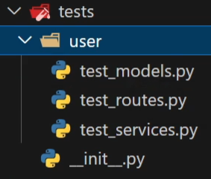
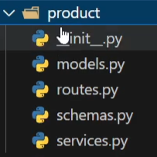
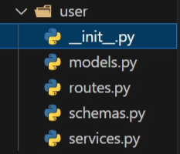
Applications: Testing:

Swagger auto generated document :
Hit this in browser http://127.0.0.1:8000/docs
Another method redoc ui FastAPI - ReDoc
Requirements.txt:
For making the file : Pip freeze > requirements.txt
For installing : Pip install –r requirements.txt

